**Faculty of engineering - Shoubra**

**Benha University**

# Research Article

In fulfillment of the requirements of

|  |  |
| --- | --- |
| **Department** | Engineering Mathematics and Physics |
| **Division** | ---------------------- |
| **Academic Year** | 2019-2020Preparatory |
| **Course name** |  |
| **Course code** |  |

## Title: -

Internet of Things

By:

|  |  |  |  |
| --- | --- | --- | --- |
|  | Name | Edu mail | B.N |
| 1 | احمد خالد محمد عبد الرازق سالم | ahmed195056@feng.bu.edu.eg | 55 |

**Approved by:**

|  |  |
| --- | --- |
| Examiners committee | Signature |
| Dr.Ahmed Bayoumi |  |
| Dr.Shady Elmashad |  |
| Dr.Abdelhamid Attaby |  |

# Research

In this topic I talked about internet of things I started by introduction about it then I talked about its history then about its application and at finally I talked about its pros and cons.

The code that I used:

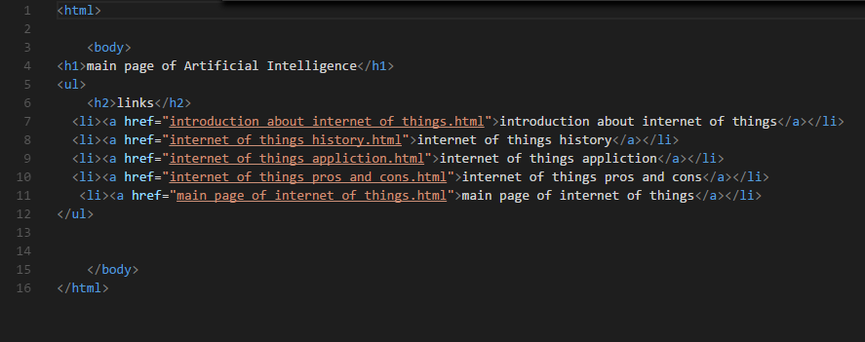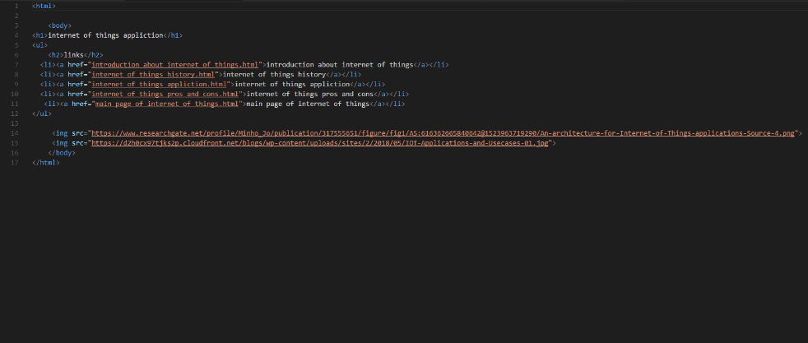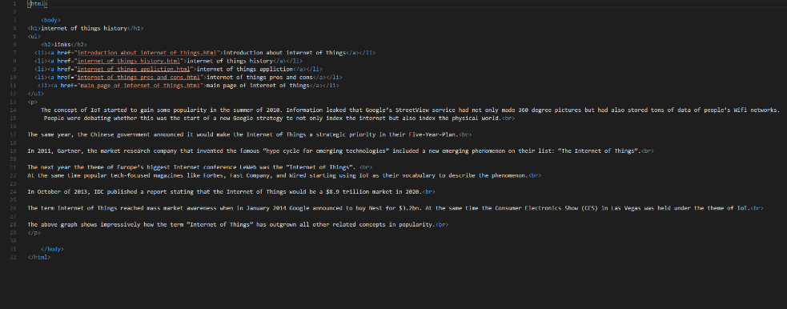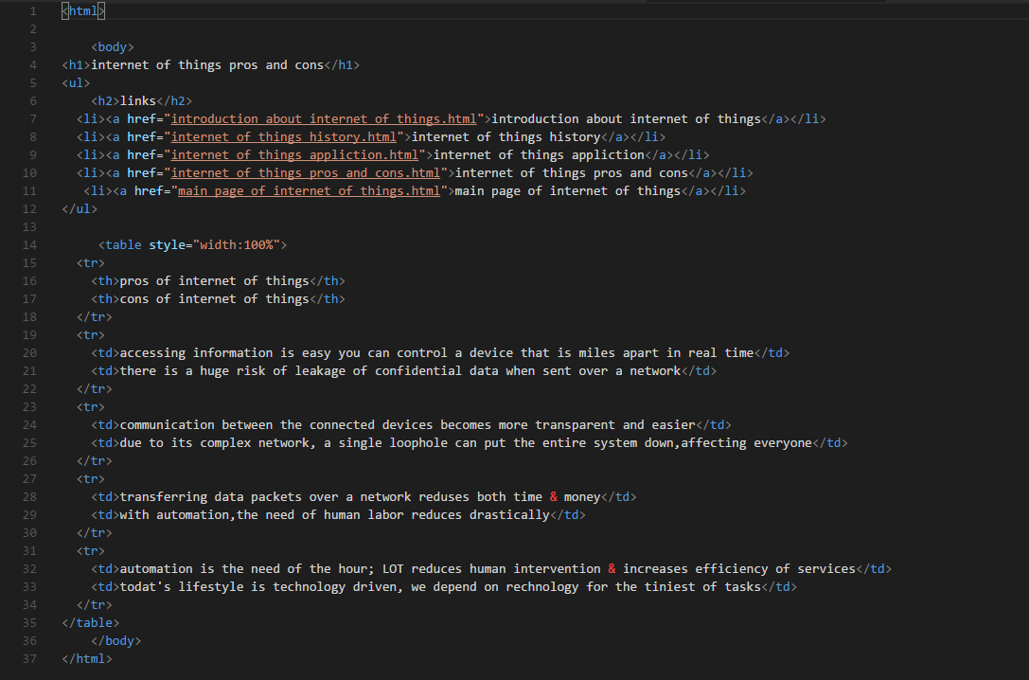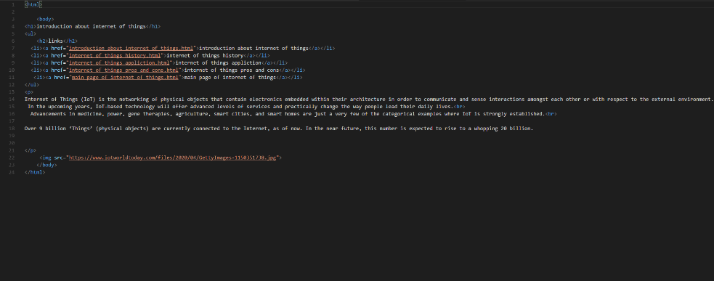

The shape of my web:

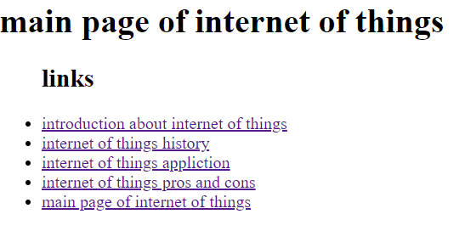

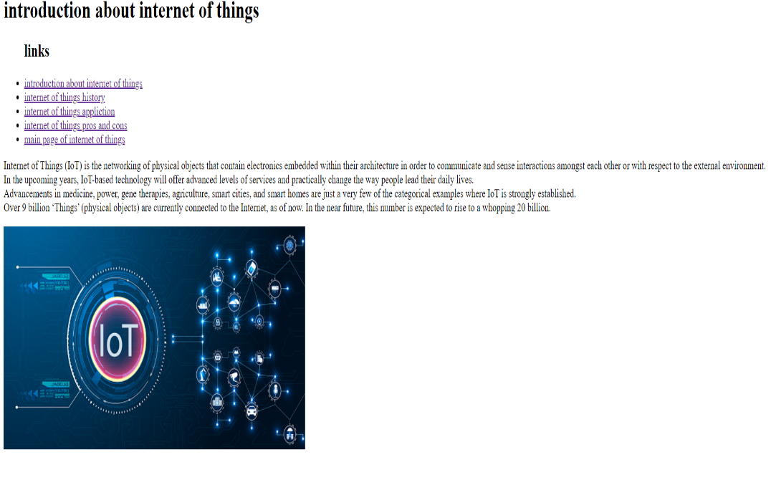

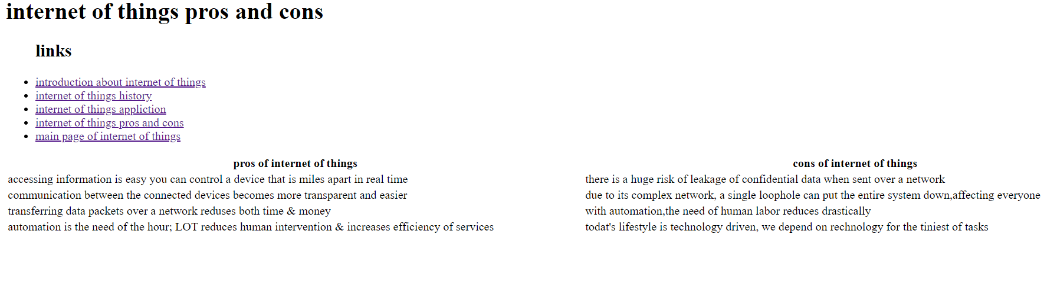

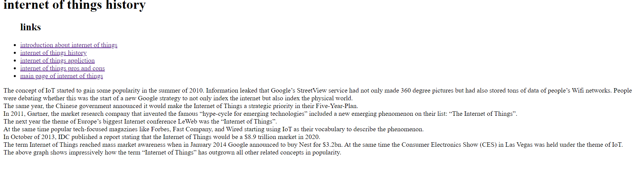

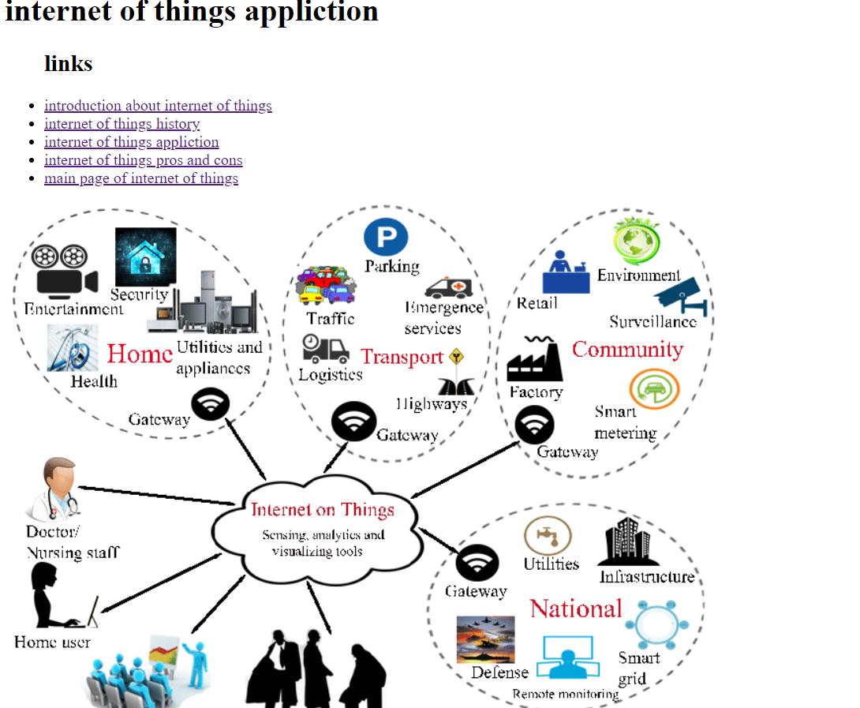

My link in GitHub:

<https://ahmed-salem2000.github.io/ece001/>

My web link:

<https://github.com/ahmed-salem2000/ece001>

# References

1. <https://iot-analytics.com/internet-of-things-definition/>
2. <https://www.redalkemi.com/blog/post/pros-cons-of-internet-of-things>
3. <https://www.geeksforgeeks.org/introduction-to-internet-of-things-iot-set-1/>